Q1

a.
ConsoleApp/Activity.java
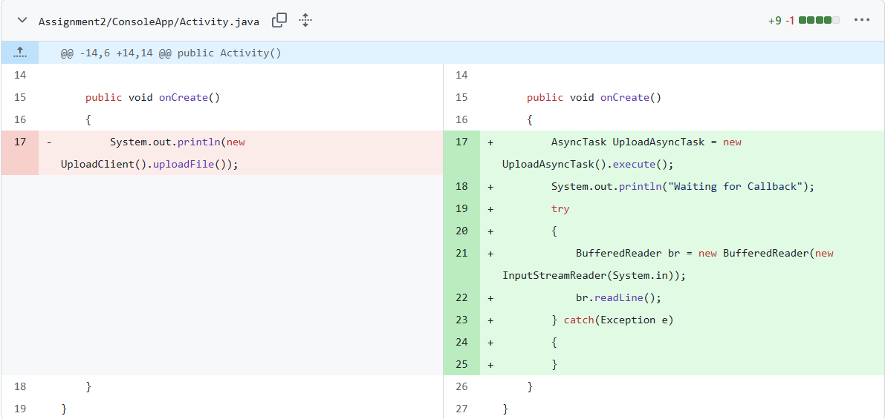
ConsoleApp/UploadAsyncTask.java
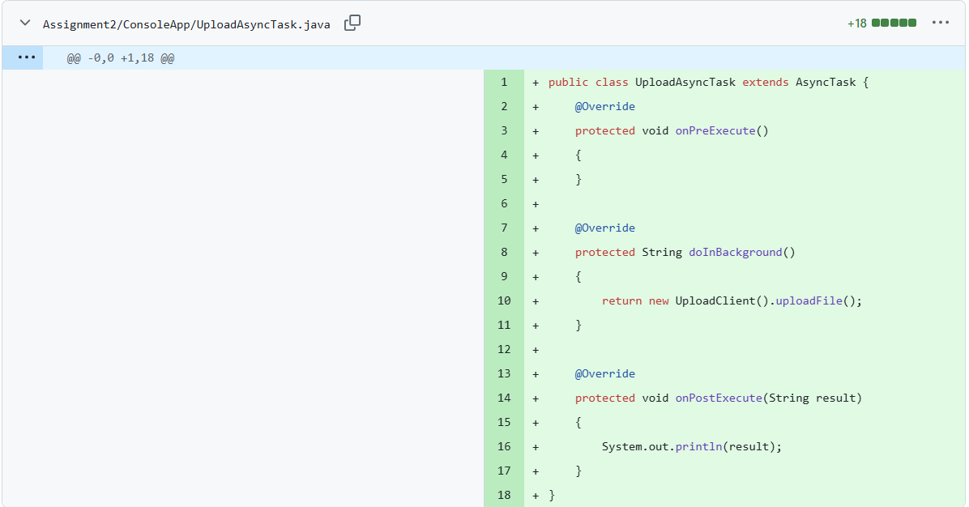

b.

A: Limit simultaneous file uploads to 3 using a fair Semaphore
UploadServer/UploadServlet.java
- Declaration and creation of the semaphore: Added import and a static, fair semaphore
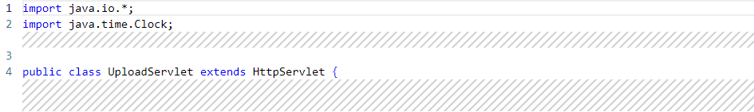
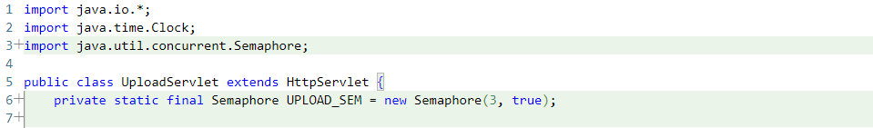
- acquire() and release(): Wrapped the existing upload handling code in doPost() with acquire/release using try/finally:
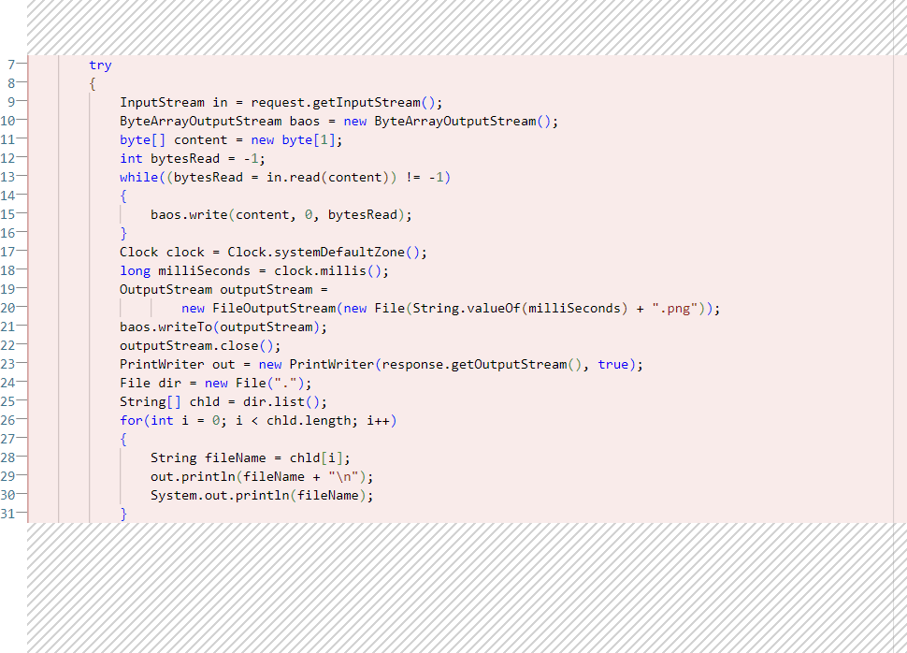
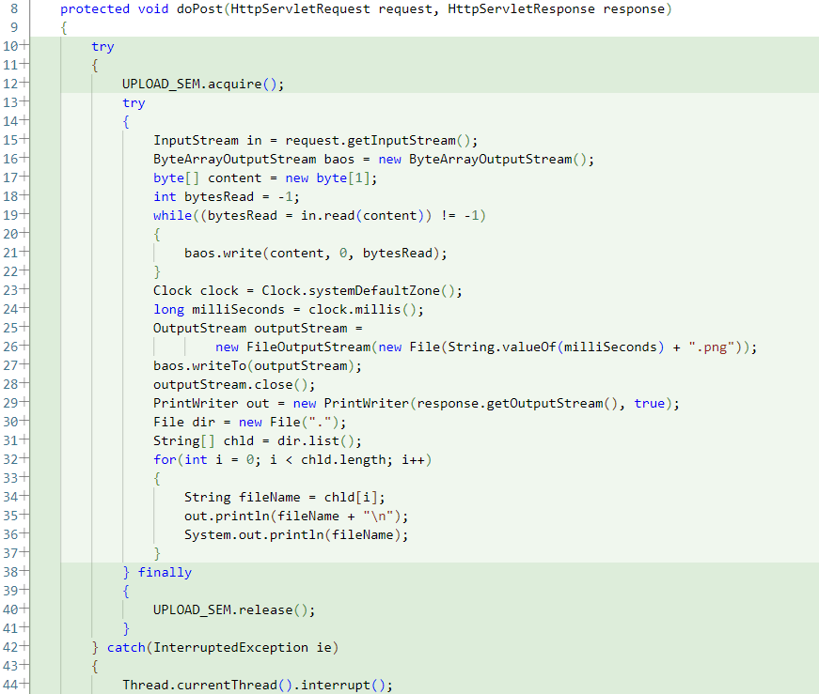

B: Limit concurrently accepted TCP connections to 3 using a fair Semaphore
- Declaration and creation of the semaphore:
Add the import and a static, fair semaphore
UploadServer/UploadServer.java
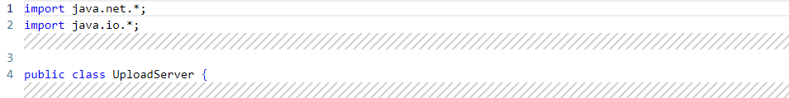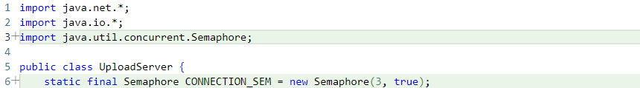
- acquire() before accepting connections:
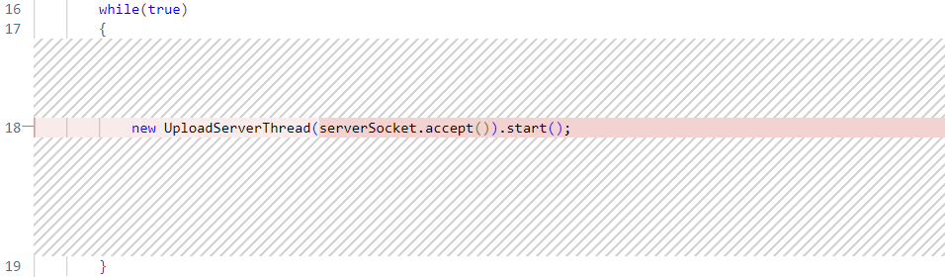
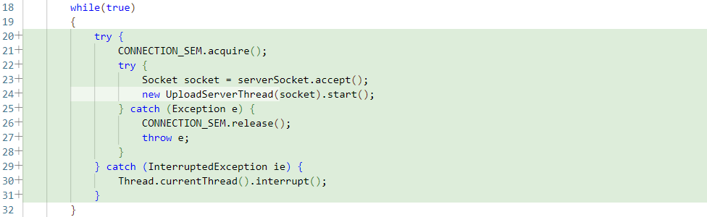
- release() when the connection-handling thread completes: release the permit in a finally block when the per-connection handling is done
UploadServer/UploadServerThread.java
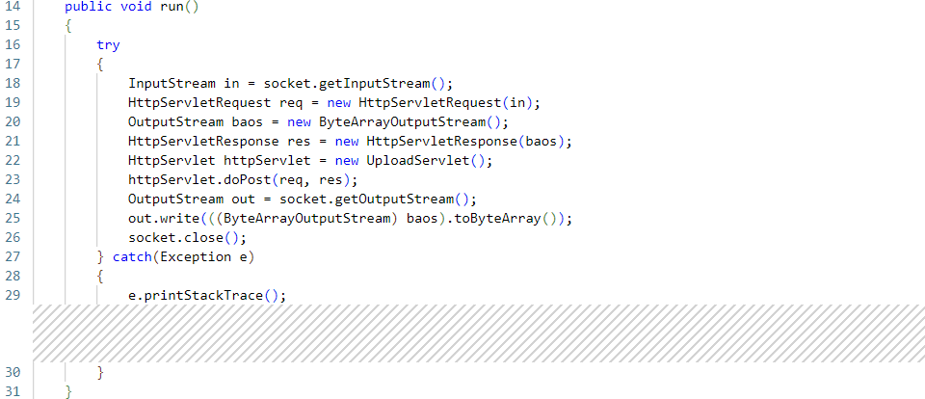
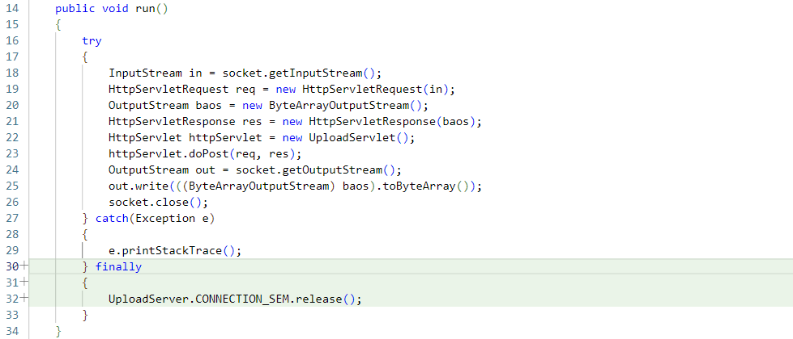

Q2

a.
T2: 1 T1: 1
T1: 1 T2: 1

b.
T1: 1 T2: 2
T2: 1 T1: 2

c.
T1: 1 T2: 2
T2: 1 T1: 2
one is safe, because only one thread can operate on the shared variable at a time

d.
